Cloud-Based Chaos Engineering & Infrastructure Monitoring
Project Documentation

Prepared by: Dhanush V
Role: MCA Graduate | Cloud & DevOps Engineer (Aspiring)
GitHub Repository: GitHub

Executive Summary
Cloud-Based Chaos Engineering & Infrastructure Monitoring is a practical DevOps project designed to demonstrate cloud infrastructure provisioning, automated deployments, monitoring, and resilience testing on AWS.
The project uses Terraform to provision infrastructure, Docker and Docker Compose to deploy applications, CloudWatch to monitor system performance, and GitHub Actions to automate container image builds. Chaos engineering techniques are applied to simulate infrastructure failures such as CPU spikes, memory exhaustion, disk utilization, and inode exhaustion, enabling analysis of system behavior under stress.
The project showcases industry-relevant skills in Infrastructure as Code (IaC), containerization, cloud monitoring, automation, and troubleshooting.

Project Objectives
The primary objectives of this project are:
- Provision cloud infrastructure using Terraform.
- Deploy containerized applications with Docker and Docker Compose.
- Implement automated deployment workflows using GitHub Actions.
- Monitor infrastructure health using AWS CloudWatch.
- Simulate real-world infrastructure failures.
- Strengthen cloud reliability through resilience testing.
- Develop practical skills in AWS and DevOps practices.

Technology Stack
Category | Technologies
Cloud Platform | AWS EC2, CloudWatch, AWS Lambda, Amazon SQS
Infrastructure as Code | Terraform
Containerization | Docker, Docker Compose
Web Server | NGINX
Application | Flask
CI/CD | GitHub Actions
Operating System | Linux (Ubuntu)
Scripting | Bash
System Architecture
The solution follows a cloud-native DevOps architecture where infrastructure is provisioned automatically and monitored continuously.

Architecture Flow
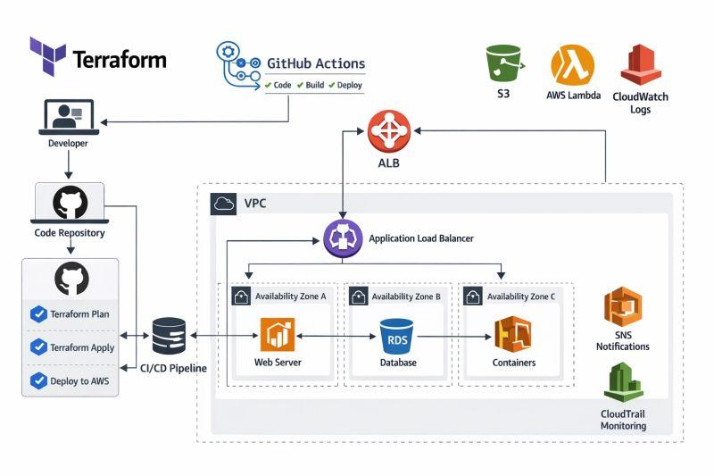
- Terraform provisions AWS EC2 infrastructure.
- Docker Compose deploys multiple application containers.
- NGINX functions as a reverse proxy.
- Flask serves the application workload.
- CloudWatch collects infrastructure and application metrics.
- AWS Lambda and Amazon SQS generate burst workloads for testing.
- GitHub Actions automates Docker image builds and deployment workflows.

Infrastructure Provisioning
Terraform is used as the Infrastructure as Code solution to provision cloud resources.
Infrastructure Components
- AWS EC2 instances
- Security Groups
- Networking configuration
- Cloud resource automation
- Repeatable infrastructure deployment
Benefits
- Consistent deployments
- Version-controlled infrastructure
- Reduced manual configuration
- Faster environment provisioning
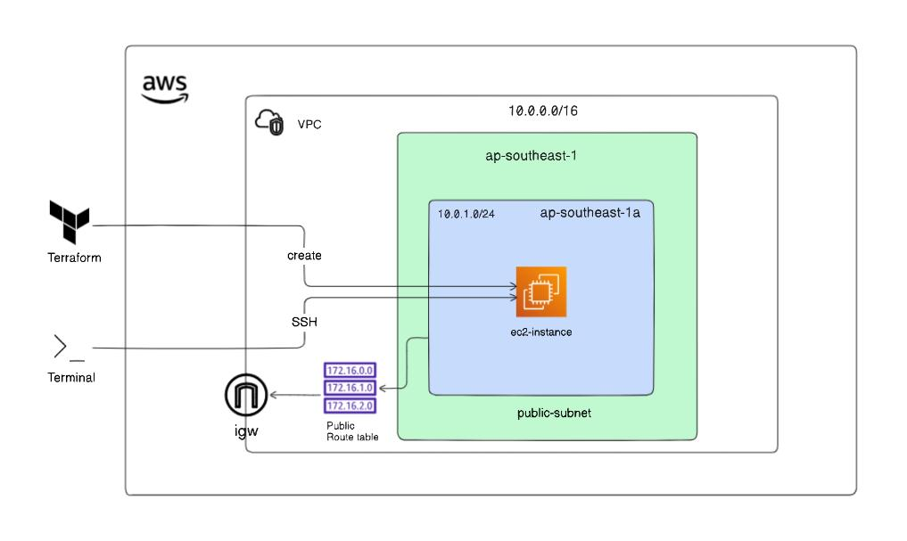
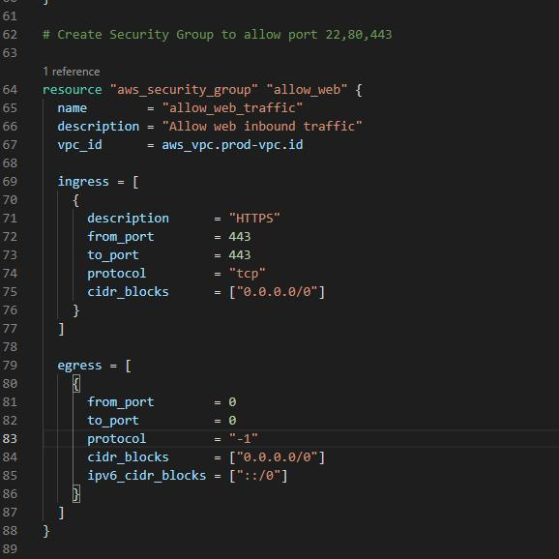
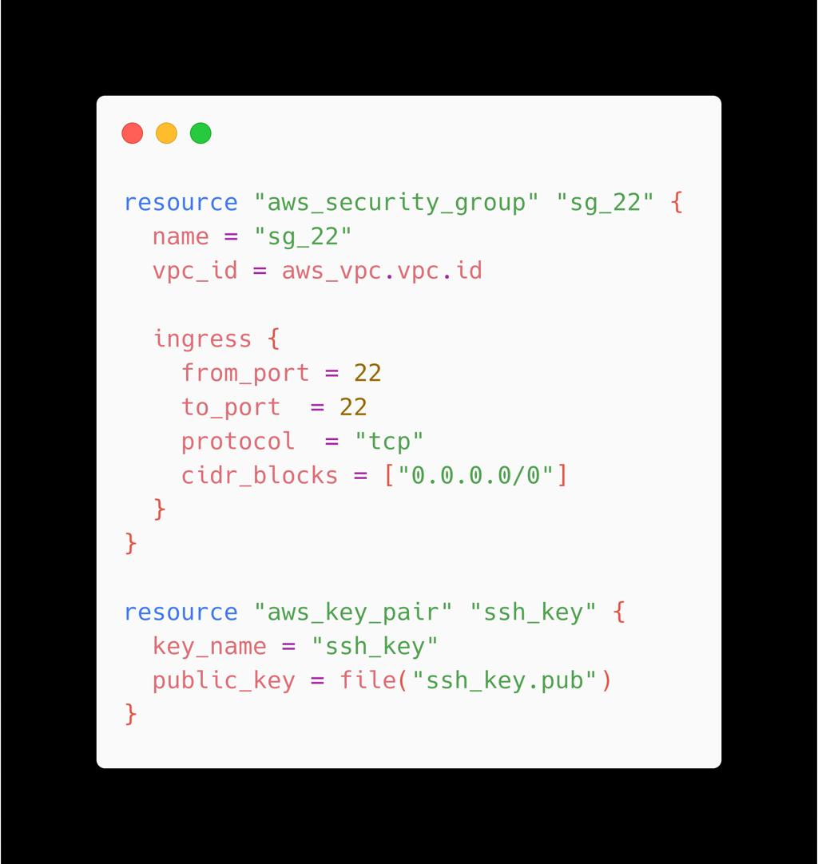

Containerized Application Deployment
Applications are deployed using Docker and Docker Compose to ensure portability and consistency across environments.
Components
- Flask Application
- NGINX Reverse Proxy
- Docker Containers
- Docker Compose Orchestration
Advantages
- Isolated application environments
- Simplified deployment process
- Easy scalability
- Consistent runtime behavior
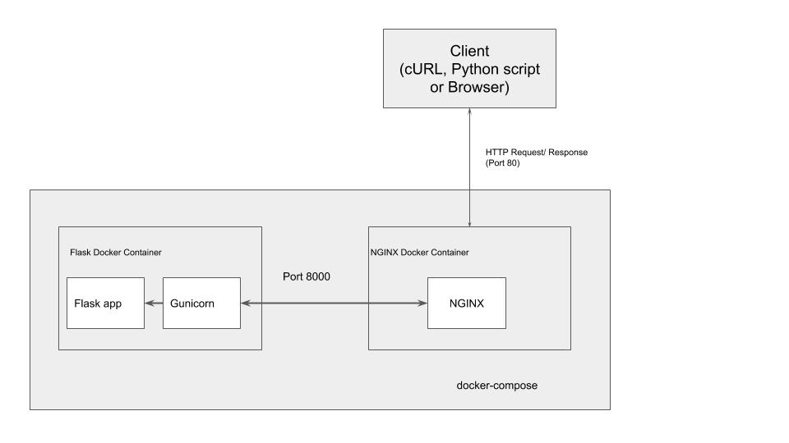
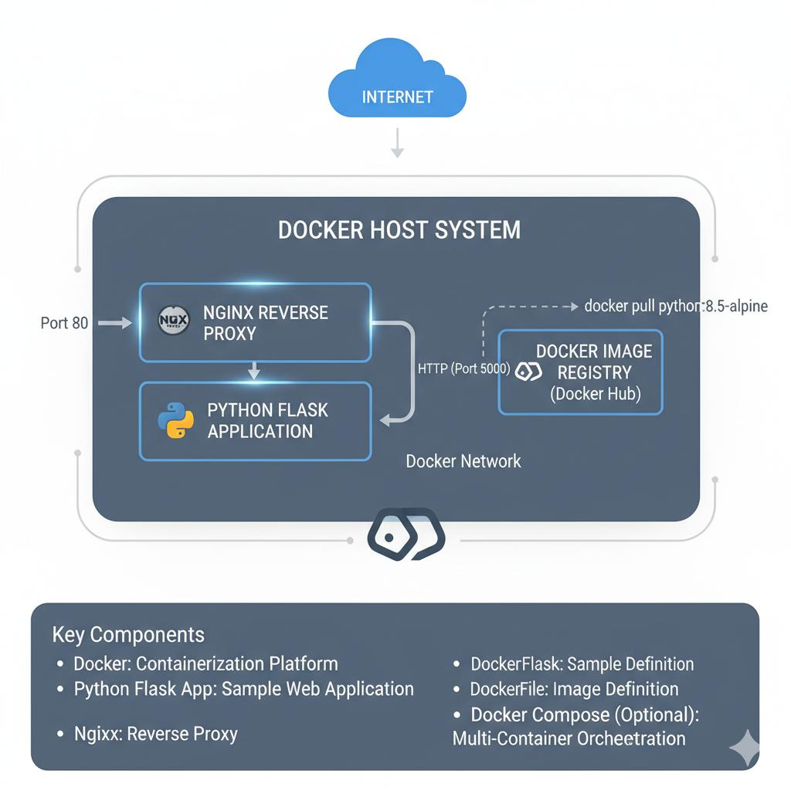
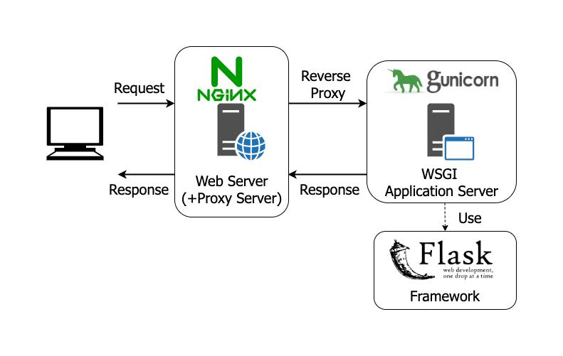

Monitoring Implementation
AWS CloudWatch provides continuous monitoring of infrastructure performance and system health.
Monitored Metrics
- CPU Utilization
- Memory Usage
- Disk Usage
- Inode Consumption
- System Logs
- Application Logs
Monitoring Benefits
- Real-time infrastructure visibility
- Faster issue detection
- Performance analysis
- Operational troubleshooting

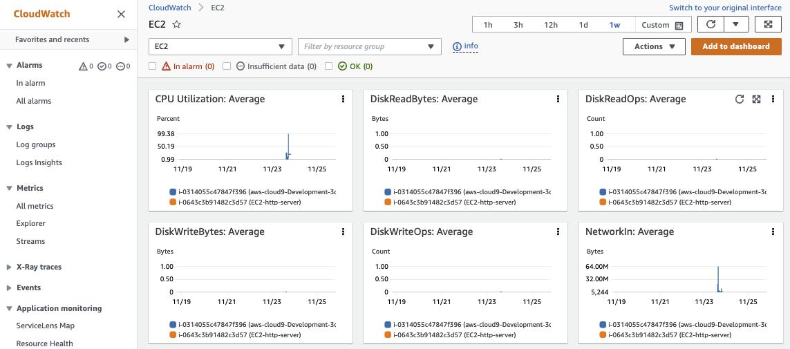
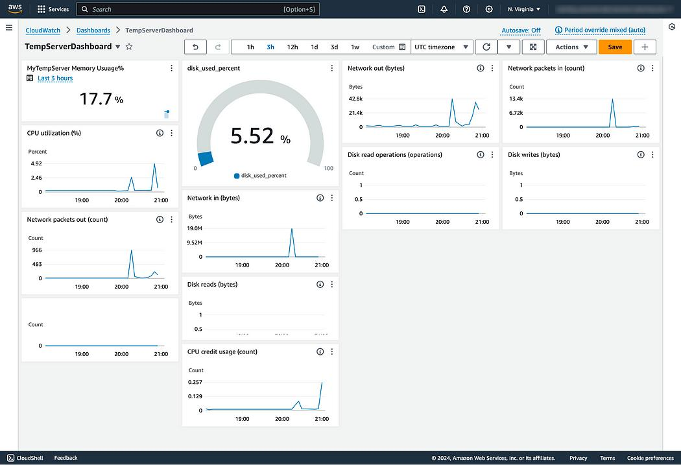

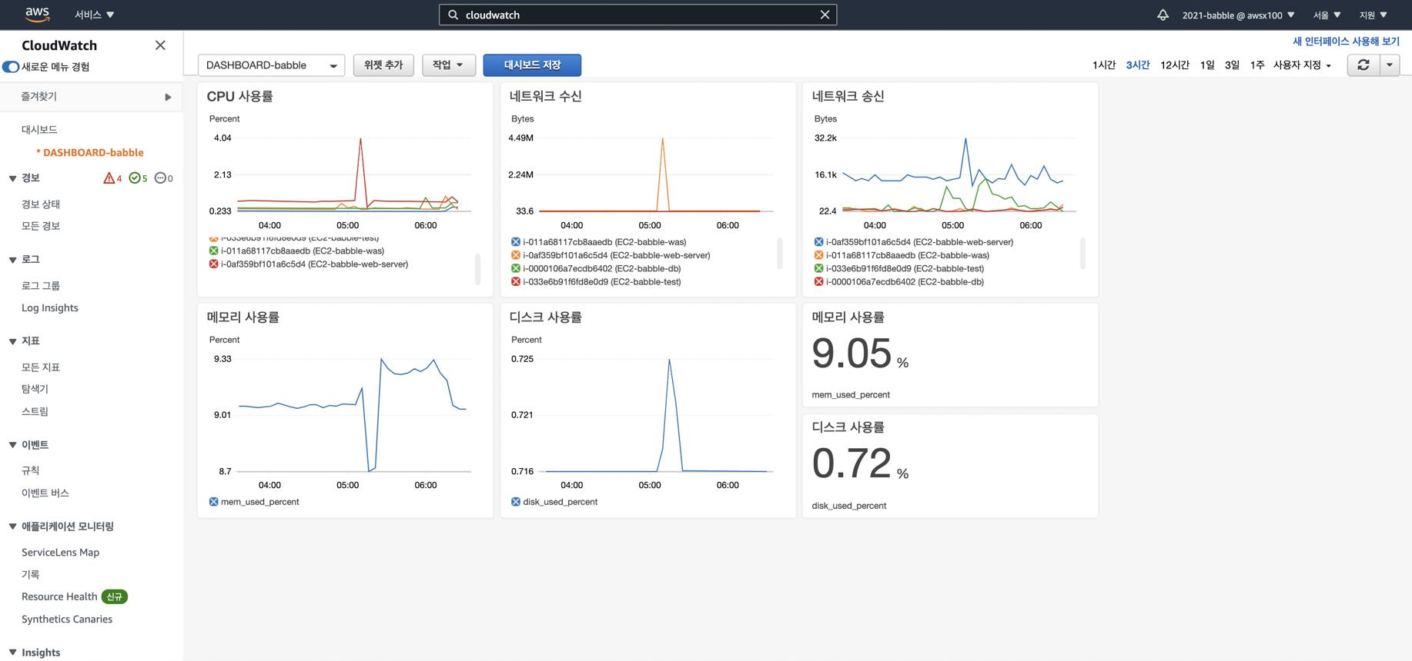

Chaos Engineering Implementation
Chaos engineering techniques are implemented to evaluate infrastructure resilience under controlled failure conditions.
Failure Scenarios
- CPU spike simulation
- Memory exhaustion
- Disk space consumption
- Inode exhaustion
- Burst workload testing using Lambda and SQS
Purpose
These experiments help observe system behavior, identify performance bottlenecks, validate monitoring alerts, and improve infrastructure reliability.

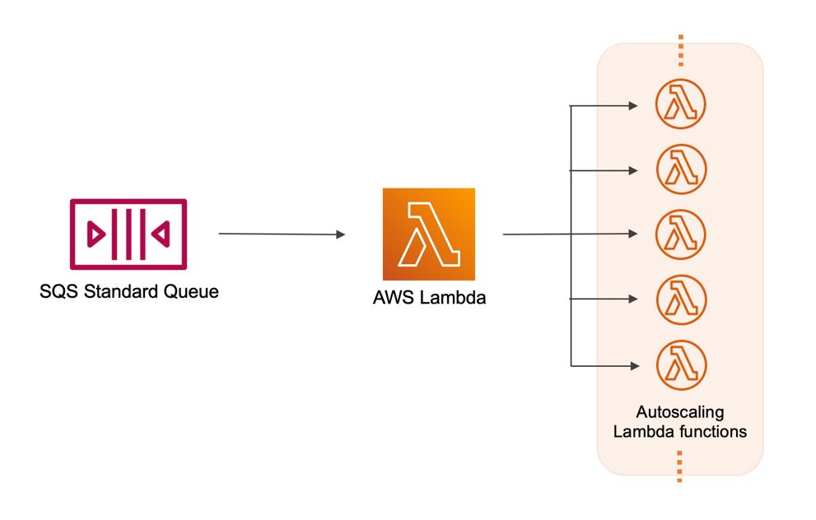
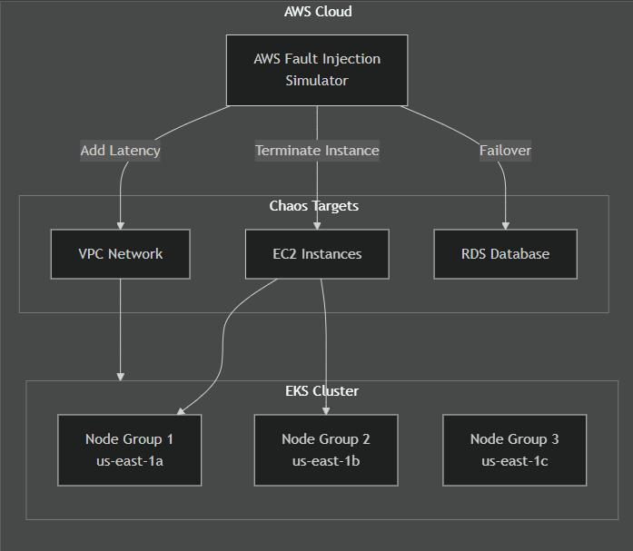
CI/CD Automation
GitHub Actions automates the application delivery pipeline.
Automated Workflow
- Source code validation
- Docker image build
- Versioned image publishing
- Deployment automation
- Rollback support through image versioning
Benefits
- Faster software delivery
- Reduced manual effort
- Improved deployment consistency
- Better release management

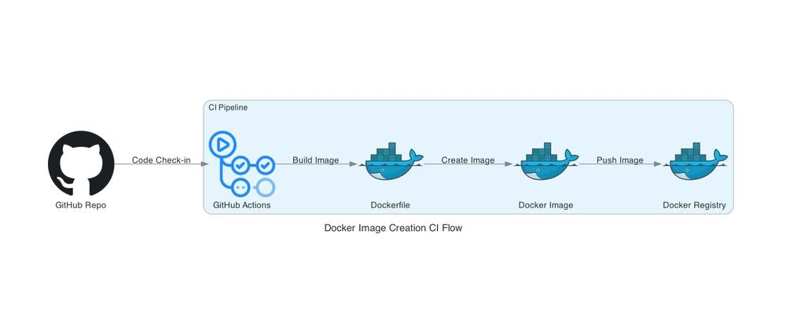
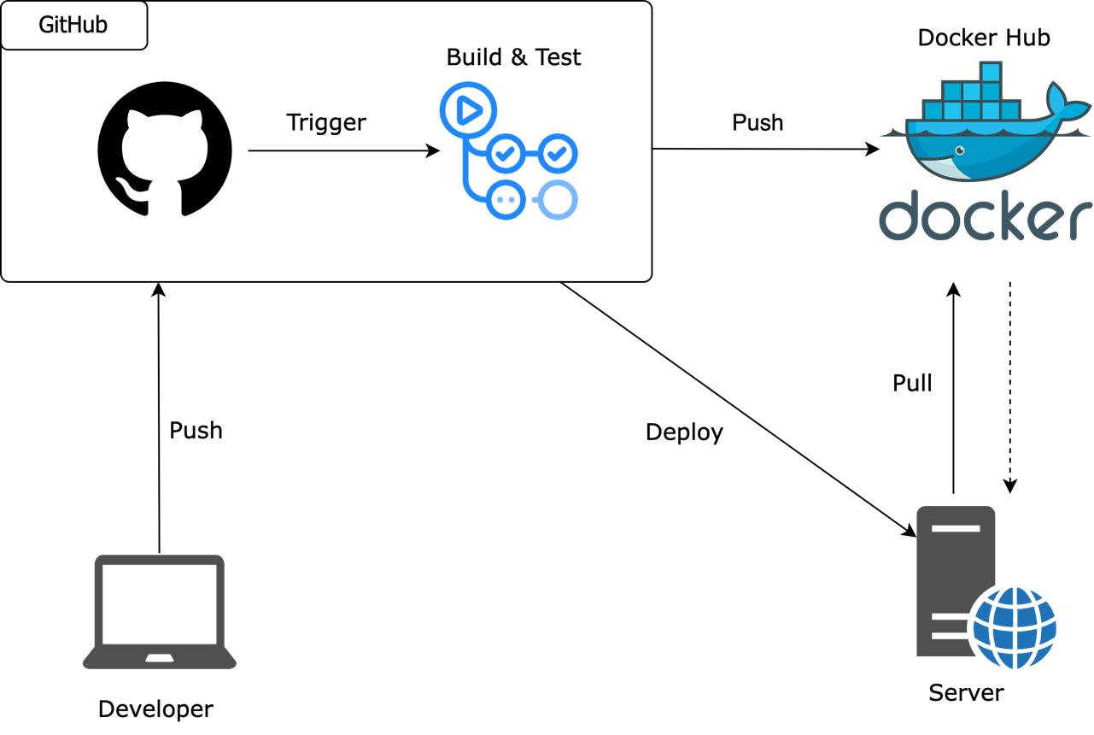
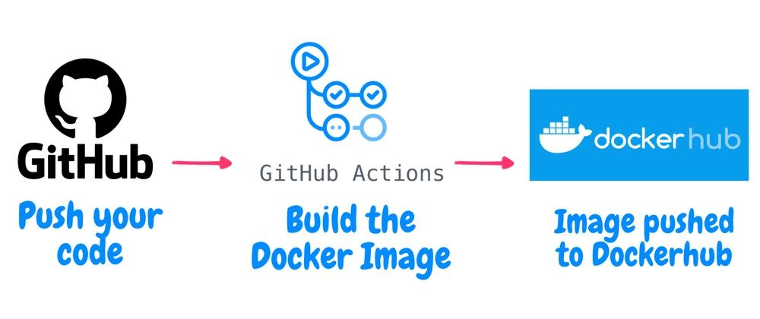

Project Workflow
The implementation follows a structured deployment process.
- Clone the repository.
- Configure AWS credentials.
- Initialize Terraform.
- Provision infrastructure using terraform apply.
- Deploy containers with Docker Compose.
- Configure monitoring.
- Execute chaos testing scenarios.
- Analyze CloudWatch metrics and logs.

Key Features
- Infrastructure provisioning with Terraform.
- AWS EC2 cloud deployment.
- Dockerized application deployment.
- NGINX reverse proxy configuration.
- CloudWatch monitoring integration.
- Lambda and SQS burst workload testing.
- GitHub Actions CI/CD automation.
- Chaos engineering implementation.
- Infrastructure troubleshooting and observability.

Challenges and Solutions
Challenge | Solution
Infrastructure provisioning | Automated using Terraform
Application deployment | Standardized with Docker Compose
Performance monitoring | Integrated AWS CloudWatch
Stress testing | Implemented controlled failure simulations
Deployment consistency | Automated using GitHub Actions
Skills Demonstrated
This project demonstrates practical knowledge of:
- AWS Cloud Infrastructure
- Terraform (Infrastructure as Code)
- Docker
- Docker Compose
- NGINX
- Flask Deployment
- AWS CloudWatch
- GitHub Actions
- Linux Administration
- Bash Scripting
- Cloud Monitoring
- Troubleshooting
- DevOps Automation
- Chaos Engineering Fundamentals

Project Outcomes
The project successfully demonstrates how modern cloud infrastructure can be automated, monitored, and tested using DevOps best practices. It highlights practical experience with cloud deployment, infrastructure automation, container orchestration, monitoring, and resilience testing, making it highly relevant for Cloud Engineer, DevOps Engineer, AWS Engineer, and Site Reliability Engineer (SRE) roles.

Repository
GitHub Repository
git@github.com:dhanushv4/chaos-lab.git
This project reflects hands-on implementation of cloud infrastructure automation, monitoring, CI/CD, and chaos engineering practices aligned with industry-standard DevOps workflows.

